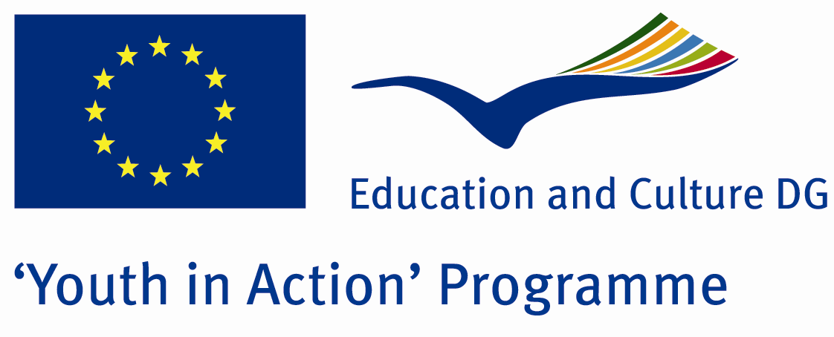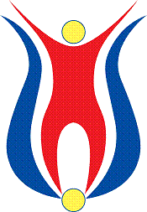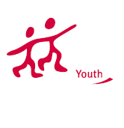

Action 1.1
Project Summary; Beykoz is a unique part of İstanbul integrated the nature with the art. It has been the host town of glass art for centuries. In addition to glass art, we invite you,the foreigners to various unique activities such as garden works in hobby gardens, dance activities in cultural spots, fotoshops. Included in some tours our Project welcomes volunteers whom wants to deal with art sorrounded by natural beauties.

Project Title; Discovery Yourself in the Art
Date and Venue ; 09-16 July Turkey
Place: İSTANBUL.

Target Group ; Municipalities, City Councils and Non-Governmental organizations,
youth groups,culture and art groups,e.t.c

Participants ; 5 people from each country (over 18 -25 ). Totally 8 countries.

Conditions ; Accommodation, board and programme costs will be financed through European Commission Youth in Action Programme . Travel costs will be reimbursed in 70% (APEX Tarrifs). Organizations from all 27 EU member countries plus Liechtenstein , Norway and Iceland are eligible to take part.

Working language: English

Organisator group: Group Saydam

How to apply: If you are interested, please send your Part III forms to
by e-mail please (in word file). Scan Part3 format is enough for application.(Fulfilled Part III which you can find in the attachment, of course signed and stamped) ..

Contact e-mail: groupsaydam@gmail.com

